BSNL Website Editing Guide
Use this guide for routine content updates. It covers News, Upcoming Events, Partnership collaborators, Team and Alumni, and the Gallery. For layout, navigation, forms, or theme changes, contact Jiayi.

Before You Edit
- Work in WordPress only. Do not edit theme files.
- Review every layout / display change on desktop and mobile before publishing.
- If a page opens in an HTML or code block, change only existing text, links, or image URLs. Do not remove surrounding tags, classes, or section IDs.

1. News
Where: Posts > Add New or Posts > All Posts
Use News for announcements, recaps, opportunities, alumni updates, and recruitment posts.
- Add a clear title and the article text.
- Add a Featured image. This becomes the cover image on the News page and homepage. A landscape image of 1600 x 1000 px works best.
- Select the appropriate category, normally News.
- In BSNL display author, enter the public byline when it should differ from the WordPress account name. Leave it empty to use the account author.
- Preview, then publish.
Note: The title, summary, and cover image on a News card all link to the post. News also appears in the homepage News section. Posts in Upcoming Events are excluded from News.

2. Upcoming Events
Where: Posts > Add New or Posts > All Posts
- Add the event title and post text.
- Select Upcoming Events as the category.
- In BSNL event details, complete Event date and time, Location and short calendar summary. The rest of the parts are optional.
- Preview and publish.
Note: Upcoming events are normal posts with the Upcoming Events category. They feed the Events calendar automatically, and the nearest four future events feed the homepage.

To change or cancel an event, edit the same post. To remove it from the calendar, unpublish it or remove the Upcoming Events category. Do not edit the Events page calendar directly.

3. Collaborators
Where: Collaborators in the WordPress sidebar
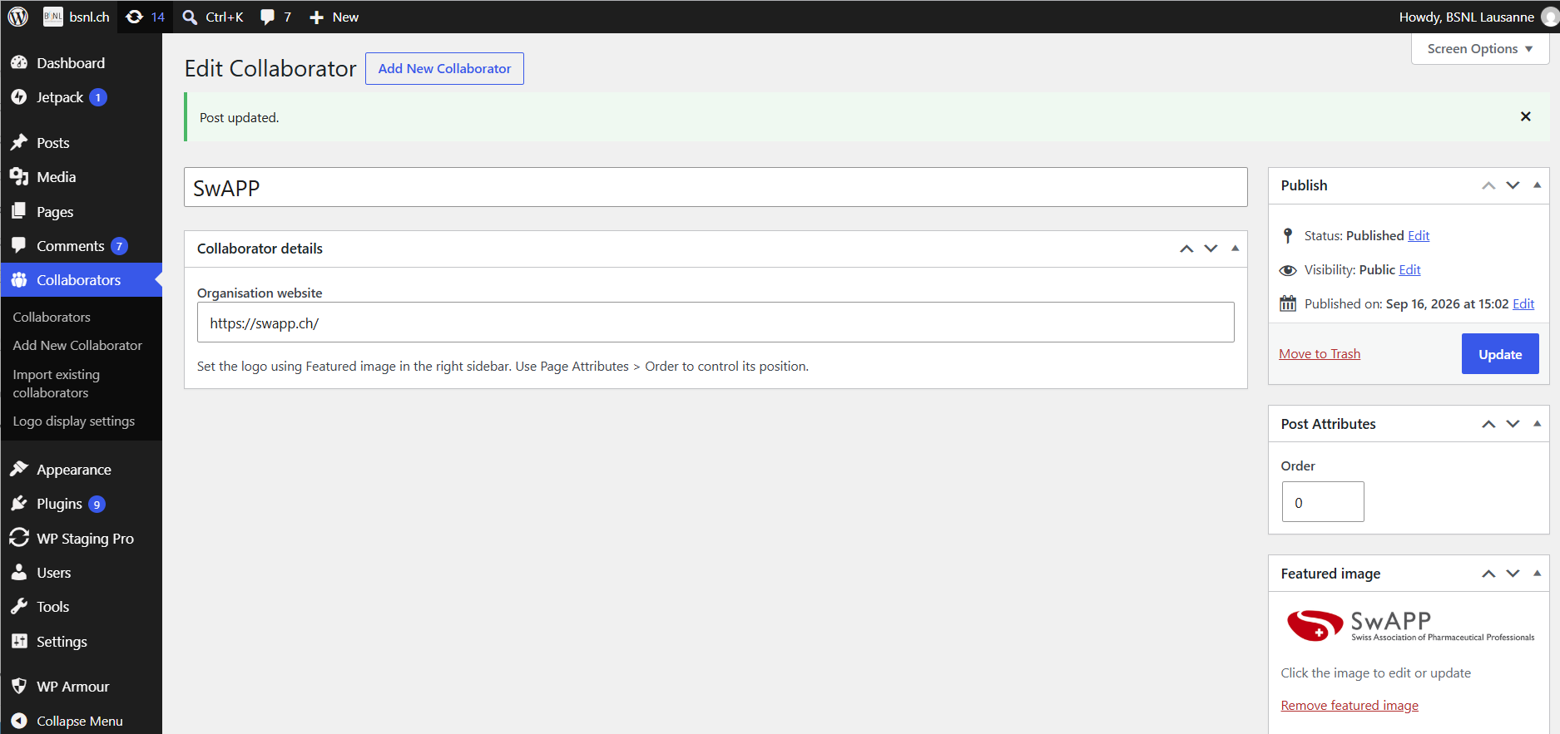
The Partnership page displays published Collaborator entries automatically. Do not add logos directly into the Partnership page HTML.
- Go to Collaborators > Add New.
- Enter the organisation name as the title. Set an official logo as the Featured image.
- In Collaborator details, add the complete organisation website URL, beginning with https://.
- Collaborators > Logo display settings to adjust the full grid. If one logo still looks small, crop excess blank space from the original image and upload the cropped logo as its Featured image
- Use Page Attributes > Order to position the logo. Lower numbers appear first; items with the same order are alphabetical.
- Publish.

4. Gallery
Where: Pages > About Us, in the Gallery section
- Open Pages > About Us > Edit and find the Gallery section.
- Replace an existing image using the Media Library or duplicate a complete existing gallery tile to add another item.
- Update the title and short caption below the image.
- Check the gallery carousel on desktop and mobile after updating.
Note: Keep the structure. Do not remove gallery carousel wrappers, slide classes, dot controls, or the section ID. They control the carousel and mobile gallery navigation.

When to Ask the Maintainer
- Page layout, spacing, fonts, colours, header, footer, or mobile menu.
- Navigation labels or dropdown structure.
- Events calendar logic, homepage dynamic sections, pagination, or shortcodes.
- Any HTML that is not clearly one existing card, image, text, or link.
Before publishing to the live site, check the edited page, linked destinations, News and Events listings, and mobile layout.

